**FAISAL RASOOL QAZI**

**455689**

**ME-15 SEC-B**

**ASSIGNMENT 01**

**TASK 01**

#include <iostream>

using namespace std;

int main() {

int number;

cout << "Enter a positive integer: ";

cin >> number;

for (int i = 1; i <= number; ++i) {

if (number % i == 0) {

cout << i << " * ";

}

}

return 0;

}

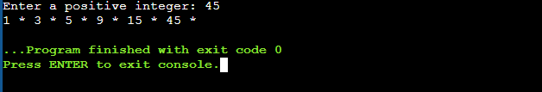

**TASK 02**

#include <iostream>

int main() {

int x = 5;

int y = 10;

if (x == 5)

if (y == 10)

std::cout << "x is 5 and y is 10" << std::endl;

else

std::cout << "x is not 5" << std::endl;

return 0;

}

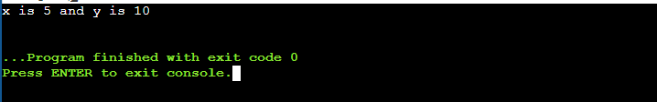

**TASK 03**

#include <iostream>

using namespace std;

int main() {

int userInput;

cout << "Enter an integer: ";

cin >> userInput;

if(userInput>10 && userInput<=20)

{

cout<<"1";

}

else

{

cout<<"0";

}

}

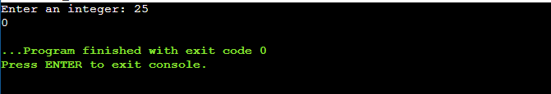

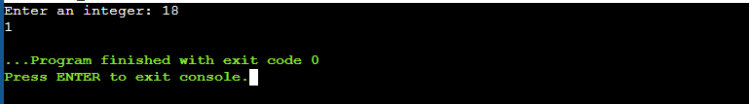

**TASK 04**

#include <iostream>

using namespace std;

int main() {

int integer, z=0;

bool x;

cout<<"Enter an integer : ";

cin>>integer;

for(int i=2; i<=integer; i++)

{

x=true;

for(int j=2; j*j<=i; j++)

{

if(i%j==0)

{

x=false;

break;

}

}

if(x)

{

z=i;

}

}

cout<<"The largest prime number less than "<<integer<<" is "<<z<<endl;

return 0;

}

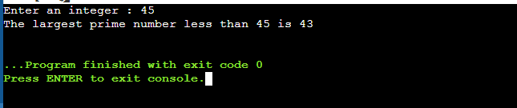

**TASK 05**

#include <iostream>

#include <algorithm>

#include <string>

using namespace std;

int main()

{

string s1, s2;

cout<<"Enter a string :";

cin>>s1;

cout<<"Enter another string:";

cin>>s2;

if(s1==s2)

{

rotate(s1.begin(), s1.begin()+1, s1.end());

cout<<"Both strings are equal, rotating first string: "<<s1<<endl;

}

else

{

cout << "Strings are already unequal." << endl;

}

return 0;

}

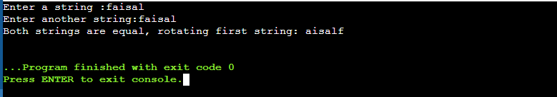

**TASK 06**

#include <iostream>

using namespace std;

int main()

{

double x, y, ans;

cout<<"ENTER DIVISOR : ";

cin>>x;

cout<<"ENTER DIVIDEND : ";

cin>>y;

ans = x/y;

cout<< x <<" / "<< y <<" = "<<ans;

return 0;

}

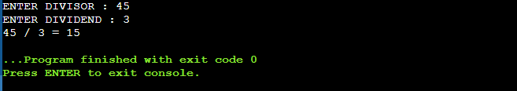

**TASK 07**

#include <iostream>

#include <string>

using namespace std;

int main() {

string x;

cout << "Enter a string: ";

cin >> x;

int z[256] = {0};

for(char ch:x)

{

z[tolower(ch)]++;

}

string y= "";

for (char ch:x)

{

if (z[tolower(ch)]!=0)

{

y= y+ch;

z[tolower(ch)]=0;

}

}

cout << "Resultant string after removing duplicates is " << y;

return 0;

}

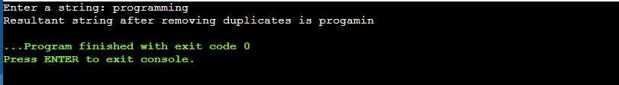

**TASK 08**

#include <iostream>

using namespace std;

int main() {

int a[5]={1, 2, 3, 4, 5};

a[5] = 6;

a[6] = 7;

a[7] = 8;

a[8] = 9;

a[9] = 10;

for (int i = 0; i < 10; i++) {

cout << "a[" << i << "]: " << a[i] << endl;

}

return 0;

}

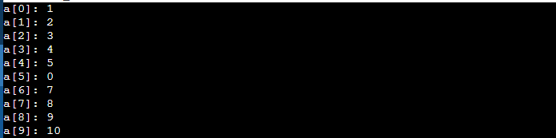

**TASK 09**

#include <iostream>

using namespace std;

int main() {

int x;

cout << "Enter a number to represent as a triplet :";

cin >> x;

for (int i=0; i<=x; i++)

{

for (int j=i+1;j<=x;j++)

{

for (int k=j+1;k<=x;k++)

{

int a[3]={i,j,k};

int sum=a[0]+a[1]+a[2];

if (sum== x)

{

cout<<a[0]<<" "<<a[1]<<" "<<a[2]<<endl;

}

}

}

}

return 0;

}

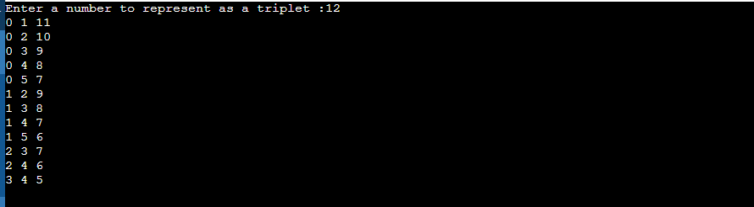

**TASK 10**

#include <iostream>

using namespace std;

void bubbleSort(int arr[], int n) {

for (int i = 0; i < n-1; i++) {

for (int j = 0; j < n-i-1; j++) {

if (arr[j] > arr[j+1]) {

int temp = arr[j];

arr[j] = arr[j+1];

arr[j+1] = temp;

}

}

}

}

int main() {

int arr[6];

cout << "Enter 6 integers:\n";

for (int i = 0; i < 6; i++)

{

cin >> arr[i];

}

bubbleSort(arr, 6);

cout << "Sorted array: ";

for (int i = 0; i < 6; i++)

cout << arr[i] << " ";

cout << endl;

return 0;

}

